**System Identification and Human Heart**

System identification is a method to obtain mathematical model of dynamic systems. It is useful to predict the behavior of the system and it provides us to opportunity to calculate or control the desired behavior.

In this experiment, we will use system identification to model a person’s heart rate response to different conditions. Since human neural system consists of billions of neurons, it is impossible to obtain a precise model of the heart rate response. Also due to its complexity, the response won’t be linear (i.e. if we double the input, heart rate won’t get doubled). However, we can determine some operating points and for each of them we can obtain different models and controllers. We don’t want to use a single operating point and controller since the accuracy of the model decreases when output deviates from the determined operating point due to heart’s nonlinearity.

**Polar FT-7 Heart Rate Transmitter/Monitor**

The heart rate transmitter used in this experiment is Polar FT-7. The product consists of 3 parts:

* Chest Strap: Basically an interface between the body and the transmitter.
* Heart Rate Transmitter: Wireless heart rate sender
* Hear Rate Monitor Watch: Receives the heart rate data and prints it on its screen

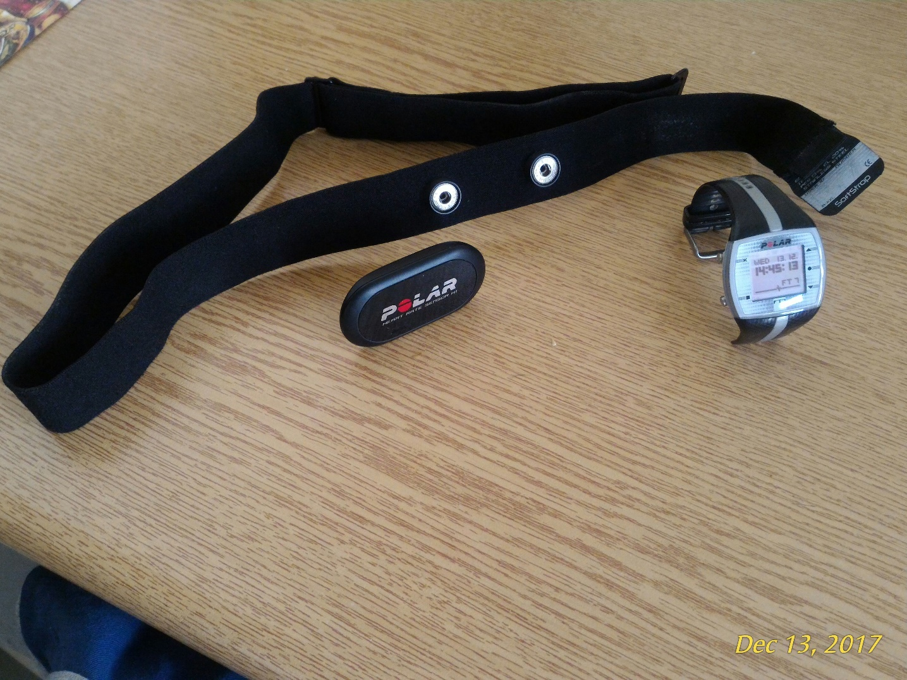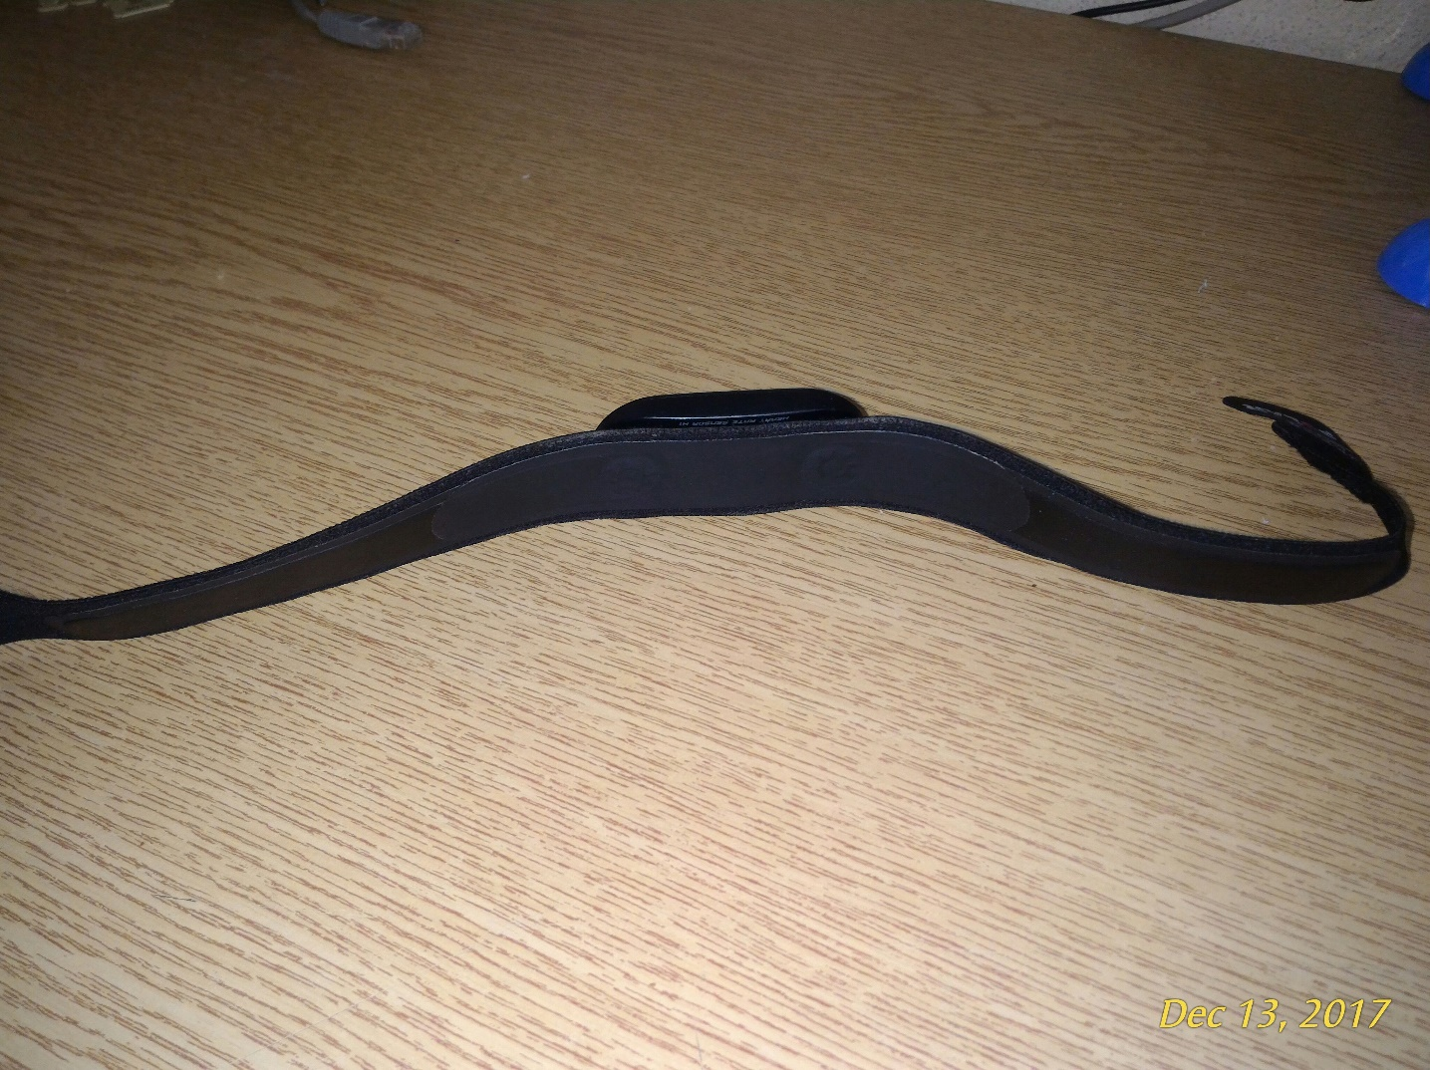

Chest Strap

HR Monitor Watch

The Strap’s Body/Device Interface

HR Transmitter

**Polar Treadmill (Model bilinmiyor)**

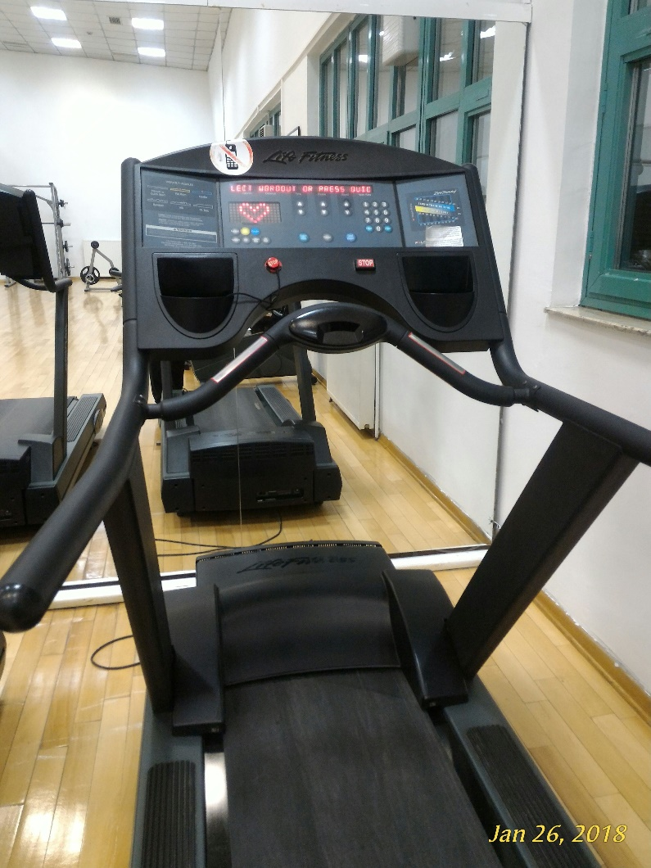**Life Fitness 9500 HR Treadmill**

The treadmill is used to control the running conditions (speed and track incline) precisely. It also displays the received heart rate information to its screen automatically, when the Polar FT-7 is used as HR transmitter. Also, the treadmill has a number keyboard so that the desired speed can be directly given as input to it. The METU Sport Center has 6 of these treadmills and they are free to use to the students.